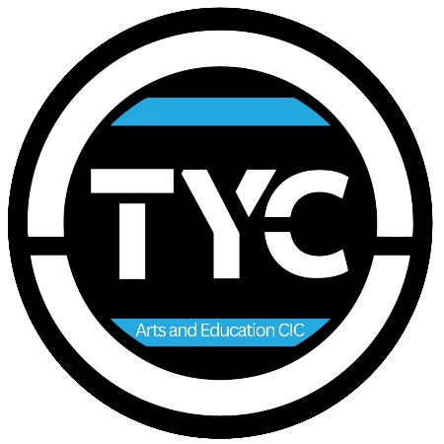

Paid Creative Opportunity

(Pilot Role)

TYC Merch Maker

We are currently piloting a new paid creative production role at TYC and are looking for one young creative to join us behind the scenes as a Merchandise Maker.
This role is ideal for someone who enjoys practical, hands-on creative work and takes pride in producing high-quality outcomes. It is a making-focused role, suited to a young person who enjoys process, detail, and repetition as much as design and ideas.
This is a pilot opportunity, initially offered on a trial basis, with the intention to review and potentially extend or expand the role based on demand and fit.

About the role
The Merchandise Maker will support the production of TYC uniforms and merchandise using vinyl printing techniques. This includes preparing designs, cutting vinyl, pressing garments, and quality checking finished items.
The role will take place in our studio one afternoon weekday per week, while the TYC team are already on site.

Payment
This is a paid role, with payment made per item or per batch produced, rather than hourly.
This flexible structure allows the role to fit around school and other commitments, while ensuring creative work is fairly rewarded.
Payment rates will be shared with those invited to apply.

This role would suit someone who:
- Enjoys making and hands-on creative work
- Likes working carefully with small details
- Is comfortable with repetition and process
- Takes pride in neat, high-quality finishes
- Works calmly and independently
- Has creative ideas and an interest in production or design

What we offer
- Full training in vinyl cutting and garment printing
- A supportive, calm studio environment
- Paid creative work
- Real-world skills in creative production and enterprise
- Opportunity to help develop future merchandise and show-related designs
- A pilot role with scope to grow following review

How to express interest
Parents or young creatives can contact us via info@theyoungcreativesportsmouth.co.uk to register interest – please send a paragraph or a video stating what excites you about the role.
Suitable applicants will then be invited to apply or have an informal conversation.

