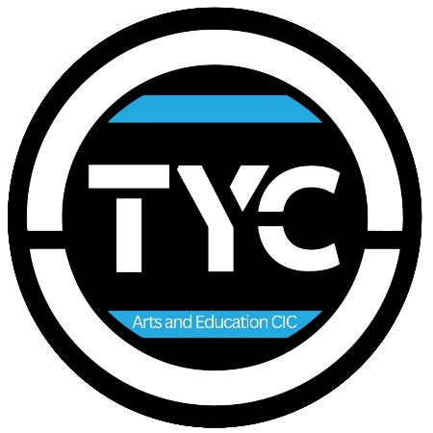

Job Description

Admin Assistant (Arts Organisation Support)
TYC Arts and Education CIC

TYC Arts and Education CIC is a youth-led arts organisation based in Portsmouth and Havant, supporting children and young people aged 5–25 through drama, film, music, and creative projects. We work across weekly classes, holiday programmes, schools, and funded projects, with youth voice at the heart of everything we do.
We are looking for a friendly, organised, and creative Admin Assistant to work alongside the Artistic Director, supporting the day-to-day running of the organisation.
This is a flexible, part-time role ideal for someone who enjoys admin but also wants to be involved in the creative side of an arts organisation.

Key Information
- Employer: TYC Arts and Education CIC
- Role: Admin Assistant
- Hours: 6 hours per week (approx. 1 day a week)
- Pay: £13 per hour
- Contract: Freelance / casual (with potential to grow)
- Location: Flexible – mix of TYC office, session venues, and home working
- Reports to: Artistic Director
Hours can be worked flexibly across the week and agreed in advance.

About the Role
This role is ideal for a young person or early-career practitioner who is interested in gaining hands-on experience of creative production, arts administration, and project delivery within a youth-led organisation. You’ll be supported to learn our systems and gain a broad understanding of how creative projects are developed and delivered.
The Admin Assistant will support the Artistic Director with the smooth running of TYC’s weekly classes, holiday programmes (including HAF), and funded projects.
This role combines administration, communication, light project management, and creative support. You’ll help keep systems organised, information up to date, and communication flowing, freeing up the Artistic Director to focus on creative delivery and strategic development.
You don’t need to know everything already, training will be provided in our systems and ways of working.

Key Responsibilities
Administration & Systems
- Support day-to-day admin tasks across the organisation
- Learn and use our class management software (e.g. registers, bookings, data updates)
- Upload documents, policies, and updates to the website
- Keep shared folders and digital systems organised
Communication
- Liaise with parents and carers via email regarding classes, bookings, and general queries
- Support communication around weekly sessions and holiday programmes
- Assist with drafting emails, information packs, and schedules
Project & Programme Support
- Assist with the coordination and admin of HAF programmes and weekly sessions
- Help track attendance, paperwork, and basic reporting requirements
- Support light project management tasks for funded projects
Creative Support
- Assist with script writing, lesson planning, and creative prep where needed
- Help format and organise creative documents for sessions and workshops

Training & Support
- Full induction and training in TYC systems and software
- Ongoing support and check-ins with the Artistic Director
- Opportunity to learn about arts administration, project delivery, and youth-led creative work
- Potential to grow the role over time depending on funding and organisational needs

Person Specification
Essential
- Organised, reliable, and good at managing small tasks
- Confident written communication (email and documents)
- Basic IT skills (Google Drive, Word/Docs, spreadsheets)
- Friendly and professional when communicating with parents and partners
- Interest in arts, creativity, or youth work
Desirable
- Experience in admin, coordination, or project support
- Interest in how arts organisations run behind the scenes
- Creative skills (writing, drama, planning workshops, etc.)
- Experience working with or supporting children and young people
- Interest in creative production, arts management, or working behind the scenes in the creative industries

What You’ll Gain
- Paid experience working within a youth-led arts organisation
- Insight into how creative programmes and funded projects are run
- Development of admin, communication, and project coordination skills
- Opportunity to be involved in creative planning and delivery
- A supportive, flexible working environment

How to Apply
Please send a CV and a short expression of interest (written or video) to:
cic@theyoungcreativesportsmouth.co.uk
We are happy to discuss flexible working arrangements and welcome applicants from a range of backgrounds.

